Business Intelligence Reporting with SQL

📑 Table of Contents
- Project Overview
- Business Problem
- Business Objectives
- Dataset
- Data Model
- Database Tables
- Tools & Technologies
- SQL Skills Demonstrated
- Detailed Analysis
- Executive Reporting
- Power BI Dashboard
- Business Insights
- Business Impact
- Recommendations
- Conclusion

📊 Project Overview
This project demonstrates how SQL can be used to transform transactional sales data into executive-ready Business Intelligence reports.
The analysis covers:
- Trend analysis
- Cumulative analysis
- Performance benchmarking
- Part-to-whole analysis
- Data segmentation
- Executive reporting
Rather than focusing solely on SQL syntax, the project focuses on solving business problems through reusable analytical reporting tables that support strategic decision-making.

💼 Business Problem
Companies generate thousands of transactions every day. Without proper analysis, decision-makers can struggle to answer important business questions.
This project addresses questions such as:
- Are sales improving year over year?
- Which products are declining?
- Which categories drive the most revenue?
- Which customers spend the most?
- Which customers generate the most value?
- Which products should receive more investment?

🎯 Business Objectives
Analysis | Business Purpose
Change Over Time | Measure long-term business growth
Cumulative Analysis | Monitor revenue accumulation
Performance Analysis | Benchmark products against historical performance
Part-to-Whole Analysis | Identify revenue-driving categories
Data Segmentation | Group customers and products into meaningful business segments
Executive Reporting | Produce reporting-ready datasets for Power BI

🗄️ Dataset
The project uses a Star Schema consisting of one fact table and two dimension tables.

Dataset Statistics
Metric | Value
Customers | 18,484
Products | 295
Transactions | 27,659
Data Range | 2010–2014
Average Price | 486
The underlying model contains transactional sales data together with customer and product dimensions.

⭐ Data Model
The database follows a Star Schema consisting of:
- gold.fact_sales
- gold.dim_customers
- gold.dim_products
This structure separates transactional measures from descriptive customer and product attributes, providing a foundation for analytical reporting.

🗃️ Database Tables

Customers — gold.dim_customers
Column | Description
customer_key | Unique key identifying each customer
customer_id | Original customer identifier
customer_number | Business customer reference number
first_name | Customer first name
last_name | Customer surname
country | Customer country
marital_status | Customer marital status
gender | Customer gender
birthdate | Customer date of birth
create_date | Date the customer record was created

Products — gold.dim_products
Column | Description
product_key | Unique product identifier
product_id | Product ID from source system
product_name | Product name
category_id | Product category identifier
category | Main product category
subcategory | Product subgroup
maintenance | Indicates whether maintenance is required
cost | Product acquisition cost
product_line | Product family or business line
start_date | Date product became available

Sales — gold.fact_sales
Column | Description
order_number | Unique sales order number
product_key | Foreign key referencing the product dimension
customer_key | Foreign key referencing the customer dimension
order_date | Date the order was placed
shipping_date | Date the order was shipped
sales_amount | Total revenue generated
quantity | Number of units sold
price | Selling price per unit

🛠️ Tools & Technologies
- SQL Server
- SQL Server Management Studio (SSMS)
- Power BI
- GitHub

🧠 SQL Skills Demonstrated
Category | Skills
Querying | SELECT, WHERE, ORDER BY
Aggregation | SUM(), COUNT(), AVG(), MIN(), MAX()
Window Functions | SUM() OVER(), AVG() OVER(), LAG(), LEAD()
Date Functions | YEAR(), MONTH(), DATETRUNC()
Conditional Logic | CASE
Ranking | ROW_NUMBER(), RANK()
Data Modelling | Joins, Foreign Keys
Reporting | KPI Development
SQL Architecture | CTEs, Views, PARTITION BY, GROUP BY

🔍 Detailed Analysis

1. 📅 Change Over Time

Business Question
How has the business performed over time?

Purpose
Analyse sales trends across multiple years and determine whether customer and sales activity is growing or declining.

SQL Concepts
- GROUP BY
- SUM()
- ORDER BY
- YEAR()

Business Insight
Sales increased steadily from 2010 through a high point in 2013 before stabilising in 2014.

2. 📈 Cumulative Analysis

Purpose
Track cumulative revenue throughout the reporting period.

SQL Concepts
- Window Functions
- SUM() OVER()
- ORDER BY

Business Value
Cumulative analysis supports:
- Revenue forecasting
- Growth tracking
- Financial planning

3. 📊 Performance Analysis

Business Question
How is each product performing compared with its historical performance?

Key Metrics
- Current Year Sales
- Previous Year Sales
- Average Sales
- Growth

SQL Concepts
- LAG()
- AVG() OVER()
- CASE
- Window Functions

Business Value
Performance analysis helps identify:
- Best-performing products
- Worst-performing products
- Products requiring management attention
- Products exceeding or meeting target values

4. 🥧 Part-to-Whole Analysis

Business Question
Which product categories generate the most revenue?

Business Value
The analysis helps identify underperforming areas requiring strategic review while highlighting categories that generate the largest proportion of revenue.
This supports better investment prioritisation and resource allocation.

5. 👥 Data Segmentation

Business Purpose
The project segments:
- Products into cost ranges
- Customers into revenue-based groups
Customer segments include:
- VIP
- Regular
- New
This segmentation supports:
- Pricing strategies
- Inventory planning
- Personalised marketing campaigns

📋 Executive Reporting
The final objective is to convert raw transactional data into business-ready reporting datasets that executives can use to monitor performance.

👤 Customer Performance Report

Purpose
Provide a complete overview of customer purchasing behaviour.

Metrics
Metric | Description
Total Sales | Revenue generated by each customer
Total Orders | Number of completed orders
Quantity Purchased | Total units purchased
Customer Lifespan | Months between first and last purchase

Key Performance Indicators
KPI | Description
Recency | Measures customer activity
Average Order Value | Indicates customer spending
Average Monthly Spend | Measures long-term customer value

Customer Segmentation
Segment | Meaning
VIP | Highest-revenue customers
Regular | Strong purchasing behaviour
New | Recently acquired / regular customers

📦 Product Performance Report

Metrics
- Revenue
- Orders
- Customers
- Quantity
- Product Lifespan

Key Performance Indicators
- Recency
- Average Order Value
- Average Monthly Spend

Business Value
The product reporting layer supports:
- Inventory Planning
- Product Lifecycle Management
- Marketing Strategy
- Pricing Decisions
- Portfolio Optimisation

📊 Power BI Dashboard
SQL provides the analytical layer of the Business Intelligence solution, while Power BI provides the visualisation layer used to communicate findings to stakeholders and management.

Dashboard Pages
- Executive Dashboard
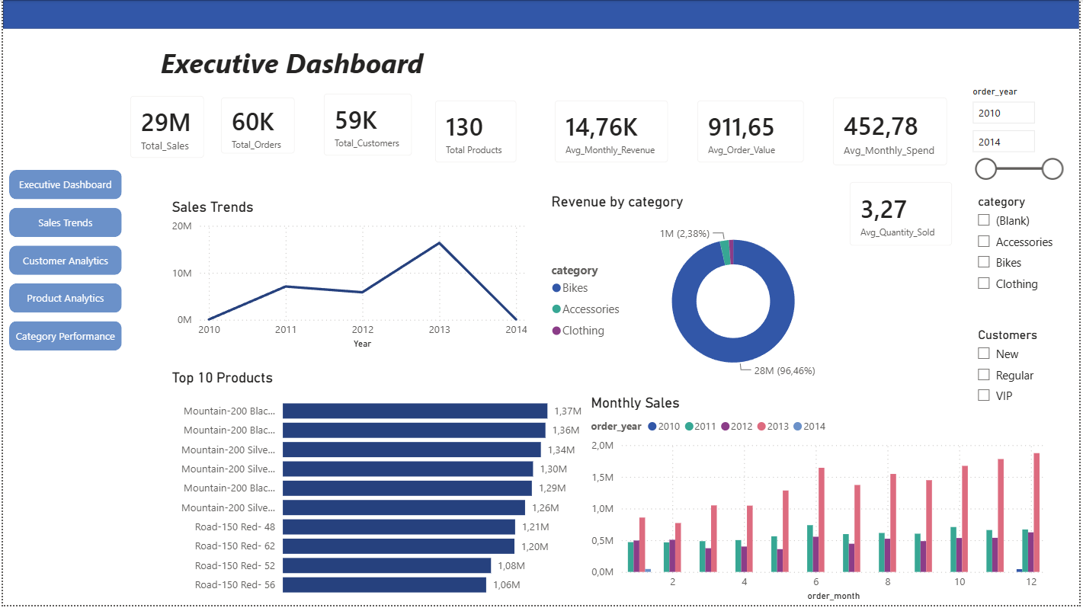
- Sales Performance Dashboard
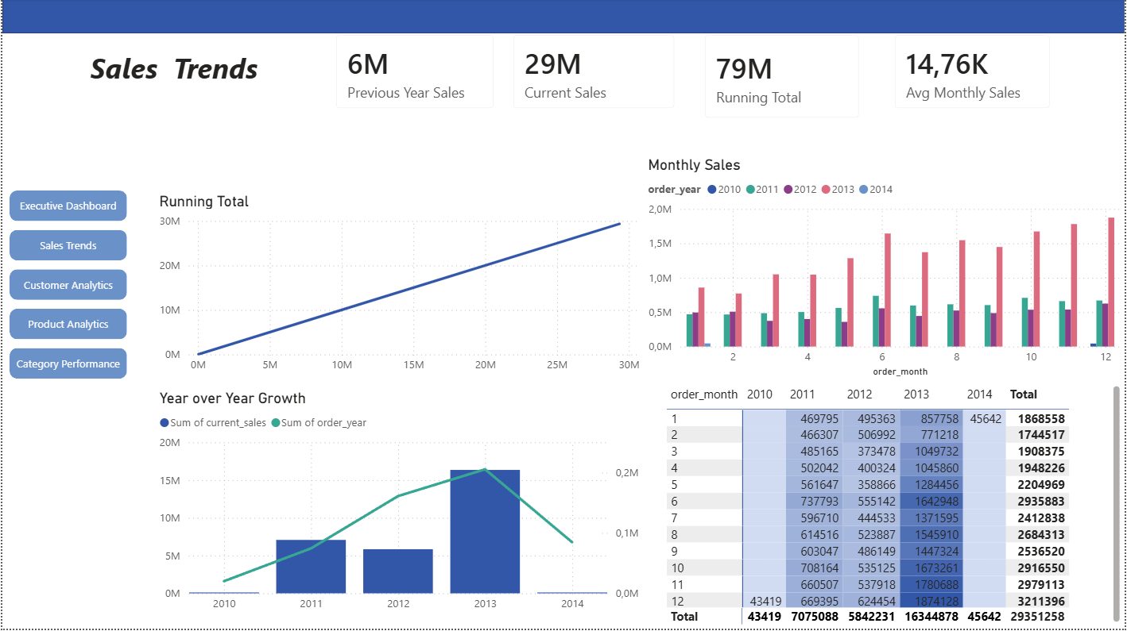

- Customer Dashboard
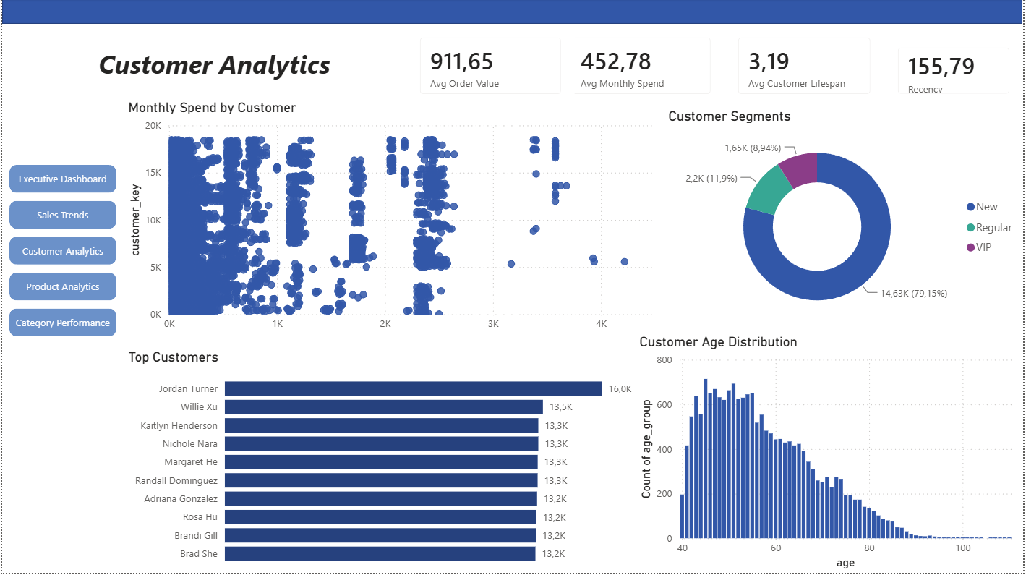
- Product Dashboard
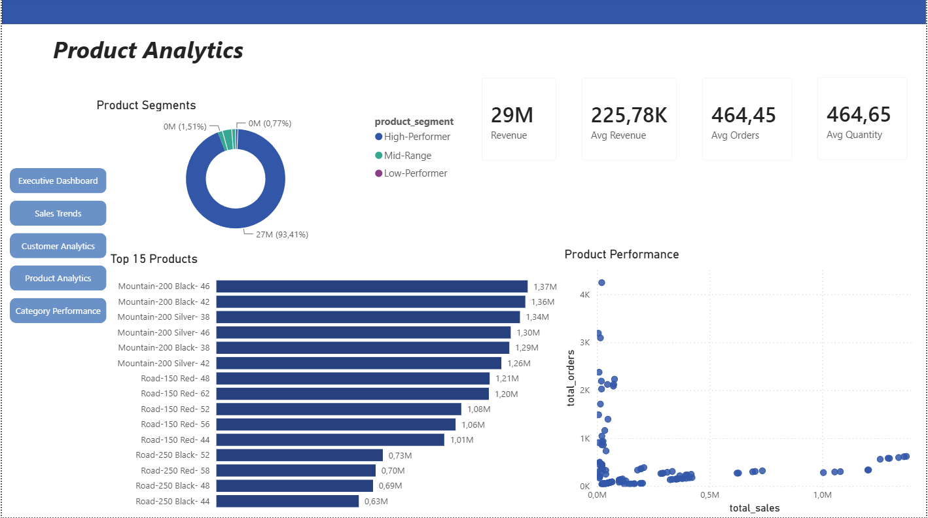

- Category Performance
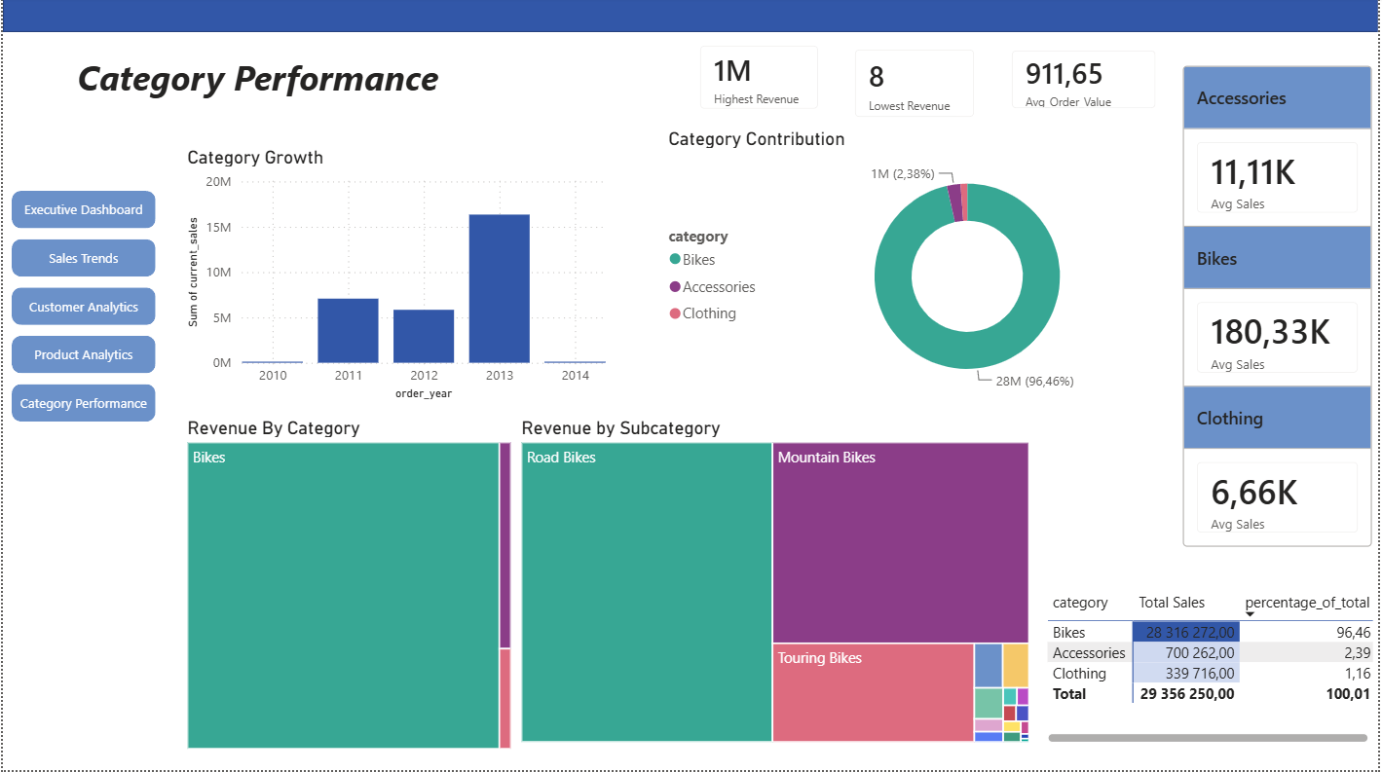
This creates an end-to-end workflow from transactional data through SQL analysis to interactive Business Intelligence reporting.

🔑 Business Insights
The analysis produced several key findings:
- Sales increased from 2010 to a high point in 2013, before stabilising in 2014.
- The Bike category generated approximately 96% of revenue, followed by Accessories at approximately 2.3% and Clothing at approximately 1%.
- Customer purchasing behaviour revealed distinct high-value and low-value customer segments.
- Average monthly spending varied significantly across customer groups.

💼 Business Impact
This reporting solution enables decision-makers to:
- Identify revenue trends.
- Monitor sales performance.
- Detect declining products.
- Prioritise high-performing categories.
- Improve customer retention strategies.
- Identify customer purchasing patterns and loyalty trends.
- Support inventory, pricing, and marketing decisions using segmented data.

🚀 Recommendations
Based on the analysis:

1. Increase Investment in High-Performing Products
Prioritise resources toward products demonstrating strong revenue and performance.

2. Review Underperforming Categories
Conduct further analysis of consistently underperforming categories, particularly Clothing and Accessories, to identify opportunities for improvement.

3. Personalise Customer Marketing
Use customer segmentation to develop targeted and personalised marketing strategies.

4. Strengthen Customer Retention
Develop retention campaigns for valuable existing customers while creating strategies to convert new customers into long-term customers

🏁 Conclusion
This project demonstrates an end-to-end Business Intelligence workflow, from data preparation and SQL analytics through to reporting-ready datasets and an interactive Power BI dashboard.
The project highlights SQL proficiency while demonstrating the ability to transform transactional data into business insights that support data-driven decision-making.

⭐ Key Portfolio Takeaway
SQL → Analytical Layer → Reporting Tables → Power BI → Business Insights → Strategic Recommendations
This workflow demonstrates how technical SQL skills can be translated into practical Business Intelligence reporting and decision support.

